

Course Project
Programming Fundamental

Date:16 january 2026

Matrix Battle Arena Presented by:
Alishba Qadeer
45647
Rozeena Saleem
45570

Presented to:
Mam Syeda Amna Rizwan

Objective:

The objective of this project is to design a simple game using C++ programming concepts in which two players are compared based on the product of elements in a 5×5 matrix.

Each player is assigned a matrix:
- Player 1 enters the matrix manually.
- Player 2’s matrix is generated randomly by the program.

The program calculates the product of all 25 elements of each matrix and compares the results.
The player with the higher product score is declared the winner.

This project aims to improve understanding of:

- Arrays and matrices
- Functions
- Pointers
- Loops
- Basic game logic

Concepts Used:

This project uses the following programming concepts:

- Arrays and Matrices

- Two-dimensional arrays are used to represent 5×5 matrices.
- Each matrix contains integer values.

- Functions

- The program is divided into multiple functions to improve readability and modularity.
- Each function performs a specific task such as input, display, or calculation.

- Pointers

- Matrices are passed to functions using pointers.
- Pointer arithmetic is used to access matrix elements efficiently.

- Loops

- for loops are used to traverse matrix elements.
- Loops help in input, display, and score calculation.

- Random Number Generation

- Random values between 1 and 5 are generated for Player 2’s matrix.
- This ensures variation in gameplay.

Code:

#include <iostream>
#include <cstdlib>
using namespace std;

const int SIZE = 5;

void inputMatrix(int *m)
{
cout << "Enter Player 1 matrix:\n";
for(int i = 0; i < SIZE*SIZE; i++)
cin >> *(m + i);
}

void randomMatrix(int *m)
{
for(int i = 0; i < SIZE*SIZE; i++)
*(m + i) = (rand() % 5) + 1;
}

void displayMatrix(int *m)
{
int k = 0;
for(int i = 0; i < SIZE; i++)
{
for(int j = 0; j < SIZE; j++)
cout << *(m + k++) << "\t";
cout << endl;
}
}

long long productScore(int *m)
{
long long product = 1;
for(int i = 0; i < SIZE*SIZE; i++)
product *= *(m + i);

return product;
}

int main()
{
int p1[SIZE][SIZE], p2[SIZE][SIZE];

inputMatrix(&p1[0][0]);
cout << "\nPlayer 1 Matrix:\n";
displayMatrix(&p1[0][0]);

randomMatrix(&p2[0][0]);
cout << "\nPlayer 2 Matrix:\n";
displayMatrix(&p2[0][0]);

long long s1 = productScore(&p1[0][0]);
long long s2 = productScore(&p2[0][0]);

cout << "\nPlayer 1 Score: " << s1 << endl;
cout << "Player 2 Score: " << s2 << endl;

if(s1 > s2)
cout << "\nPlayer 1 Wins\n";
else if(s2 > s1)
cout << "\nPlayer 2 Wins\n";
else
cout << "\nMatch Draw\n";

return 0;
}

Code Chunk 1: Matrix Input and Random Generation

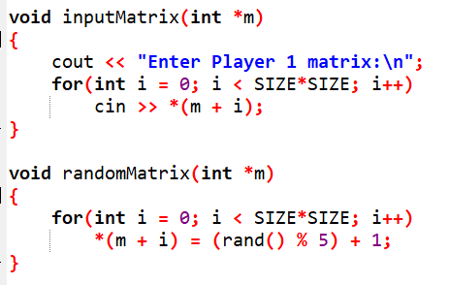

Explanation:

- inputMatrix() allows Player 1 to manually enter values for the 5×5 matrix.
- The matrix is accessed using a pointer, allowing all 25 elements to be handled in a single loop.
- randomMatrix() generates Player 2’s matrix using random values from 1 to 5.
- Zero is avoided to prevent the total product from becoming zero.

Code Chunk 2: Displaying the Matrix

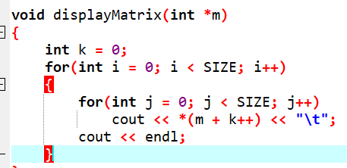

Explanation:

- This function displays the matrix in a proper 5×5 format.
- Pointer arithmetic is used to access elements sequentially.
- The output is formatted using tabs to improve readability.

Code Chunk 3: Score Calculation and Comparison

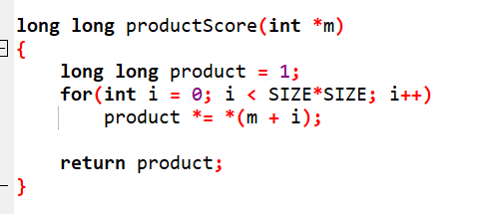

Explanation:

- This function calculates the product of all 25 matrix elements.
- long long data type is used to handle very large numbers.
- If any matrix element is zero, the final product becomes zero.
- The returned score is used to compare both players in the main() function

Output:

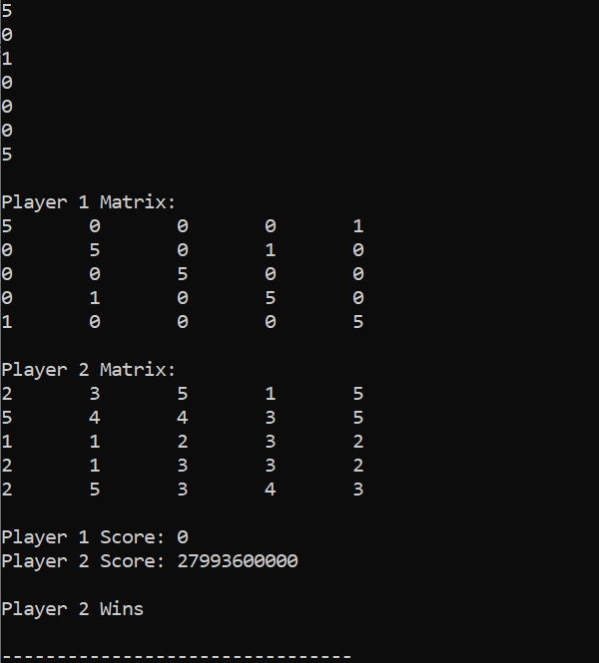
Conclusion:

In conclusion, this project successfully demonstrates the use of core C++ programming concepts through a simple matrix-based game.

The project:

- Uses 5×5 matrices for player data
- Applies functions for modular programming
- Implements pointers for efficient memory handling
- Uses loops for matrix traversal
- Calculates scores using product logic
- Compares results to determine the winner

This project enhanced understanding of arrays, pointers, functions, and logical thinking, and provided practical experience in designing a basic game structure using C++.

